DIRECTIONS TO OUR OFFICES:

At the end of the Motorway/Highway is Limassol Avenue. On Limassol Ave. you keep going straight and the name of the street at some point changes to Makarios Avenue where our offices are located.

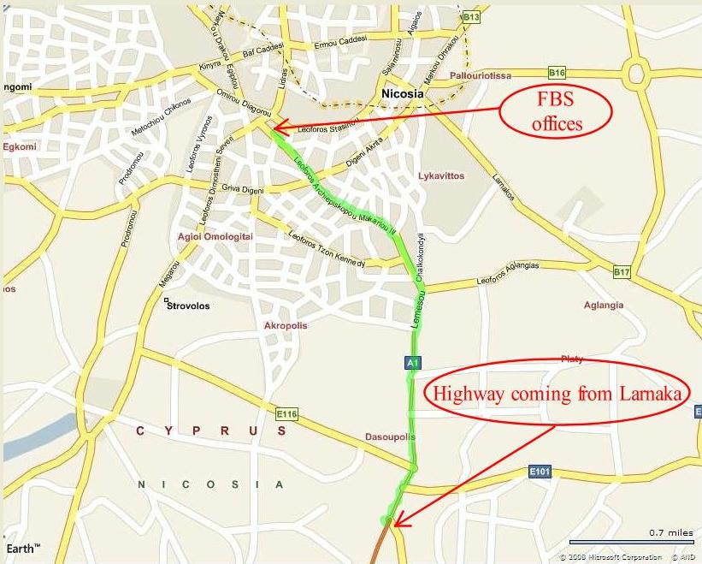

There are 7 traffic lights until you reach our offices on Makarios Avenue.

Look for landscape marks on your left hand side.
- UNICARS Dealership
- APOEL Fun Club (Football Club – Orange & Blue Building)
- Hilton Hotel (At this point Limassol Ave. changes to Makarios Avenue and you keep going straight)

Look for landscape marks on your left hand side.
- Zara store keep straight on Makarios Avenue
- Marks & Spencer store

About 300m after the Bank of Cyprus, look for Marks & Spencer store on your left hand side. Our office (Severis House) is the tall building opposite Marks & Spencer store.
The entrance of our building is located on the right side of the building.

If you are driving, there is a large parking lot opposite our offices where you can park.

